

Tech Saksham

Case Study Report

Data Analytics with Power BI

**“Supply Chain Analysis of Inventories**

**GOVERNMENT ARTS AND SCIENCE COLLEGE-IDAPPADI**

| **NM ID** | **NAME** |
| --- | --- |
| 6969BF7A4C6B2D8BA7D4BCA4D81454BA | VIKASH N |

| Trainer Name: D. PALANISAMY |
| --- |
| Master Trainer: D. PALANISAMY |

**ABSTRACT**

Inventories are critical components within supply chains, representing the stock of goods and materials held by organizations at various stages of production or distribution. Understanding the dynamics of inventories within supply chains is crucial for optimizing operational efficiency, minimizing costs, and enhancing customer satisfaction. This paper provides a comprehensive analysis of inventory management within supply chains, examining key concepts, challenges, and strategies. The analysis begins by elucidating the significance of inventories in supply chain management and their role in balancing supply and demand uncertainties. Various types of inventories, including raw materials, work-in-progress, and finished goods, are explored, along with their distinct characteristics and management requirements. Furthermore, the impact of inventory levels on overall supply chain performance, such as service levels, lead times, and costs, is thoroughly discussed. Key challenges in inventory management are identified, including demand forecasting inaccuracies, supply chain disruptions, and inventory obsolescence. Strategies for mitigating these challenges are outlined, encompassing demand forecasting techniques, inventory optimization models, and risk management approaches. Additionally, the integration of technology, such as inventory tracking systems and data analytics, is highlighted as instrumental in enhancing inventory visibility and decision-making capabilities. Finally, future trends and advancements in

inventory management within supply chains are discussed, including the adoption of artificial intelligence, blockchain technology, and sustainable inventory practices. The paper concludes by emphasizing the continuous evolution of inventory management strategies to adapt to dynamic market conditions and achieve competitive advantage in modern supply chains

## INDEX

| **Sr. No.** | **Table of Contents** | **Page No.** |
| --- | --- | --- |
| 1 | Chapter 1: Introduction | 5 |
| 2 | Chapter 2: Services and Tools Required | 8 |
| 3 | Chapter 3: Project Architecture | 10 |
| 4 | Chapter 4: Modeling and Result | 13 |
| **5** | Conclusion | **20** |
| **6** | Future Scope | **21** |
| **7** | **Link** | **22** |

**CHAPTER 1 INTRODUCTION**

##### Problem Statement

Effective inventory management is a critical aspect of supply chain optimization, yet many organizations struggle to strike the right balance between maintaining sufficient stock levels to meet demand and minimizing holding costs. Inefficient inventory management practices can lead to stockouts, excess inventory, increased lead times, and ultimately, reduced profitability. Therefore, the problem statement of this study is to identify the key challenges and opportunities in inventory management within supply chains and develop strategies to enhance efficiency, responsiveness, and overall supply chain performance

##### Proposed Solution

Optimizing inventory management within supply chains requires a strategic and holistic approach that addresses key challenges while capitalizing on opportunities for improvement. The proposed solution encompasses a series of interconnected strategies aimed at enhancing efficiency, reducing costs, and improving overall supply chain performance **Demand Forecasting Improvement**: Implement advanced demand forecasting techniques, such as predictive analytics and machine learning algorithms, to enhance forecast accuracy. By incorporating historical data, market trends, and external factors, organizations can generate more reliable demand forecasts, minimizing the risk of stockouts and excess inventory.

##### Feature

* **RFID Technology**: RFID tags embedded in inventory items enable automatic identification and tracking as they move through different stages of the supply chain.

RFID readers and antennas capture tag data, providing real-time visibility into inventory movements and enabling accurate inventory counting without manual intervention.

* **IoT Sensors**: IoT sensors deployed in warehouses, distribution centers, and transportation vehicles collect data on environmental conditions (e.g., temperature, humidity) and physical parameters (e.g., motion, vibration) affecting inventory quality and integrity. This data is transmitted wirelessly to a central database for analysis and monitoring, enabling proactive intervention to prevent damage or spoilage of inventory.
* **Inventory Management Software**: Advanced inventory management software integrates data from RFID tags, IoT sensors, and other sources to provide a comprehensive view of inventory across the supply chain. The software offers features such as inventory tracking, stock level monitoring, demand forecasting, and replenishment optimization, enabling organizations to make data-driven decisions and optimize inventory management processes.
* **Real-time Analytics:** Real-time analytics capabilities allow organizations to analyze inventory data as it is collected, enabling immediate insights into inventory trends, patterns, and anomalies. Predictive analytics algorithms forecast future demand, identify potential stockouts or overstock situations, and recommend optimal replenishment strategies to maintain optimal inventory levels and minimize costs.

### Advantages

* **Improved Inventory Visibility**: Conducting a thorough supply chain analysis of inventories enables organizations to gain a comprehensive understanding of inventory levels, locations, and movements across the supply chain. This enhanced visibility helps in identifying bottlenecks, reducing stockouts, and optimizing inventory levels to meet customer demand effectively.
* **Enhanced Operational Efficiency**: By analyzing inventory data and identifying inefficiencies in inventory management processes, organizations can streamline operations, minimize excess inventory, and reduce carrying costs. This leads to improved operational efficiency and cost savings throughout the supply chain.
* **Enhanced Customer Satisfaction**: By optimizing inventory management practices, organizations can ensure timely order fulfillment, reduce stockouts, and improve product availability. This leads to enhanced customer satisfaction, loyalty, and retention, as customers receive their orders promptly and reliably.

##### Scope

The scope of supply chain analysis of inventories encompasses a comprehensive examination of various aspects related to inventory management practices within the supply chain ecosystem. This includes assessing different types of inventories, such as raw materials, work-in-progress, and finished goods, across multiple stages of the supply chain—from procurement to distribution. The analysis extends to evaluating inventory management processes and workflows, including forecasting, ordering, replenishment, storage, and distribution, with the aim of identifying opportunities for optimization and efficiency improvement. Additionally, the scope involves exploring the use of technology solutions and tools, such as inventory tracking systems and data analytics platforms, to enhance visibility, accuracy, and decision-making in inventory management. Collaboration and partnerships among supply chain partners, risk management strategies, sustainability considerations, and regulatory compliance are also integral components of the scope. Furthermore, the scope encompasses fostering a culture of continuous improvement in inventory management practices through feedback mechanisms, employee training, and process optimization initiatives. Overall, the scope of supply chain analysis of inventories is broad and interdisciplinary, aiming to drive efficiency, reduce costs, mitigate risks, and improve overall supply chain performance.

## CHAPTER 2

**SERVICES AND TOOLS REQUIRED**

* 1. **Services Used**

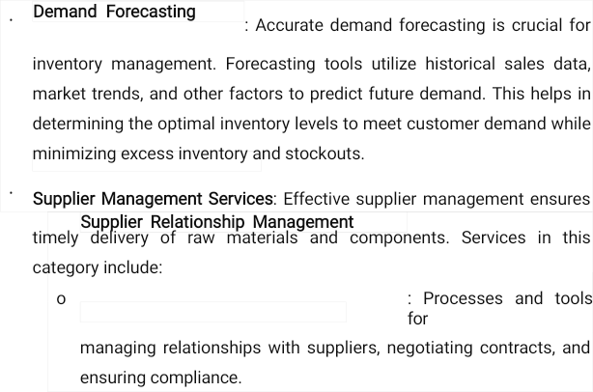

## Tools and Software used

##### Tools:

* + - **PowerBI**: The main tool for this project is PowerBI, which will be used to create interactive dashboards for real-time data visualization.
    - **Power Query**: This is a data connection technology that enables you to discover, connect, combine, and refine data across a wide variety of sources.

##### Software Requirements:

* + - **PowerBI Desktop**: This is a Windows application that you can use to create reports and publish them to PowerBI.
    - **PowerBI Service**: This is an online SaaS (Software as a Service) service that you use to publish reports, create new dashboards, and share insights.
    - **PowerBI Mobile:** This is a mobile application that you can use to access your reports and dashboards on the go.

## CHAPTER 3 PROJECT ARCHITECTURE

* 1. **Architecture**

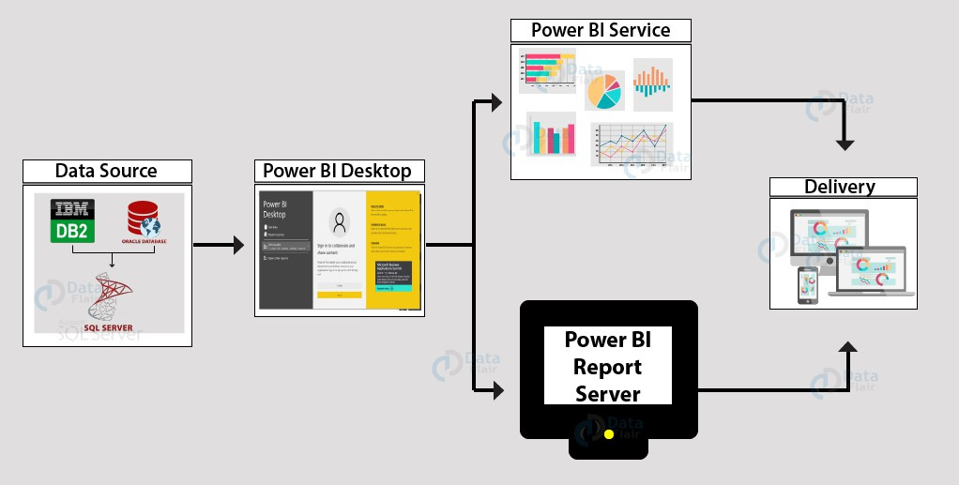

Here’s a high-level architecture for the project:

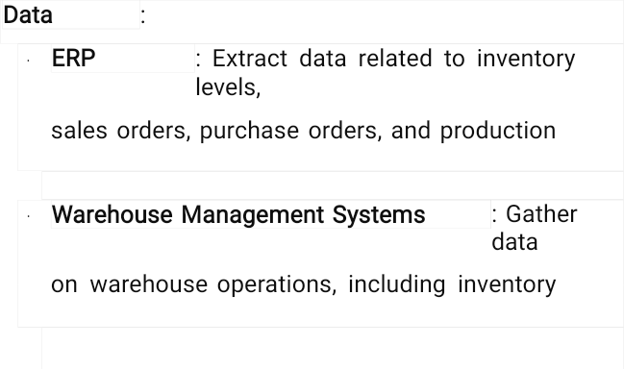

# Data Integration Layer:

* + - **ETL (Extract, Transform, Load) Processes**: Transform and consolidate data from various sources into a unified format suitable for analysis.

# Data Storage:

* + - **Data Warehouse or Data Lake**: Store integrated and cleansed data in a centralized repository optimized for analytics.
    - **Database Management System (DBMS)**: Utilize a DBMS such as SQL or NoSQL to store and manage structured and unstructured data.

**Analytics and Modeling Layer:**

* + - Inventory Optimization Algorithms: Develop algorithms to optimize inventory levels based on demand forecasts, lead times, service level targets, and cost constraints.

|  | * Demand Forecasting Models: Build predictive models to forecast   future demand using statistical methods, machine learning techniques, or time series analysis. |
| --- | --- |
| This high-level architecture outlines the components and layers involved in a Supply Chain Analysis of Inventories project, encompassing data integration, analytics, visualization, decision support, security, and continuous optimization. | |

## CHAPTER 4 MODELING AND RESULT

### Manage relationship

#### Supply Chain Analysis of Inventories involves various modeling techniques to optimize inventory levels, streamline operations, and improve supply chain efficiency. Here are some key modeling approaches commonly used in inventory analysis

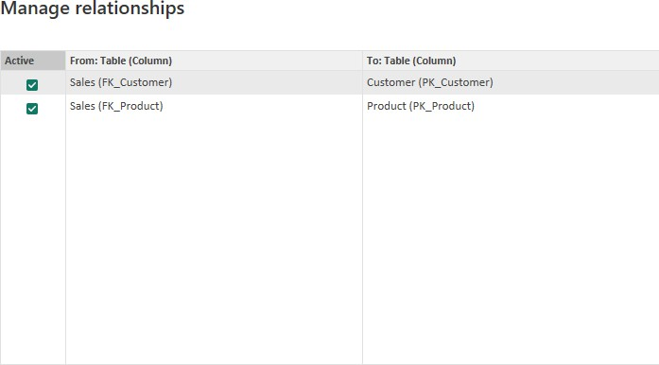

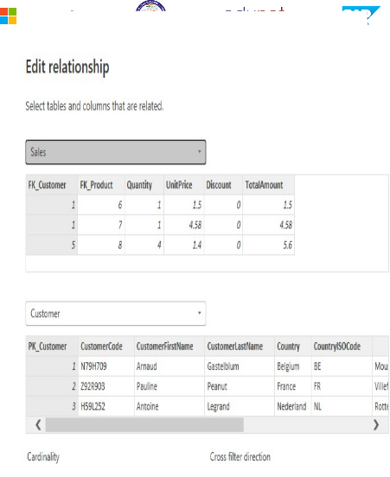

By editing or refining these relationships, organizations can improve the efficiency, effectiveness, and resilience of their supply chain analysis of inventories, leading to better performance and competitive advantage

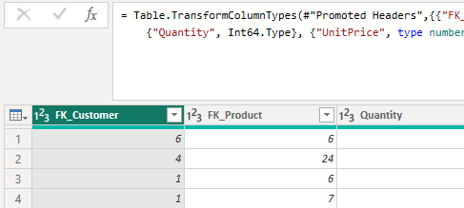

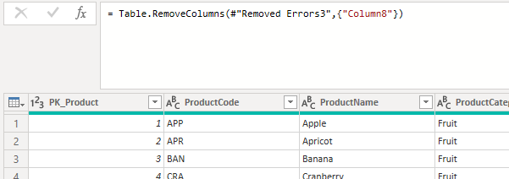

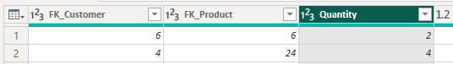

**Replacing values**

Set some fields to English for easy understanding, we replace values to English with the Power Query Editor.

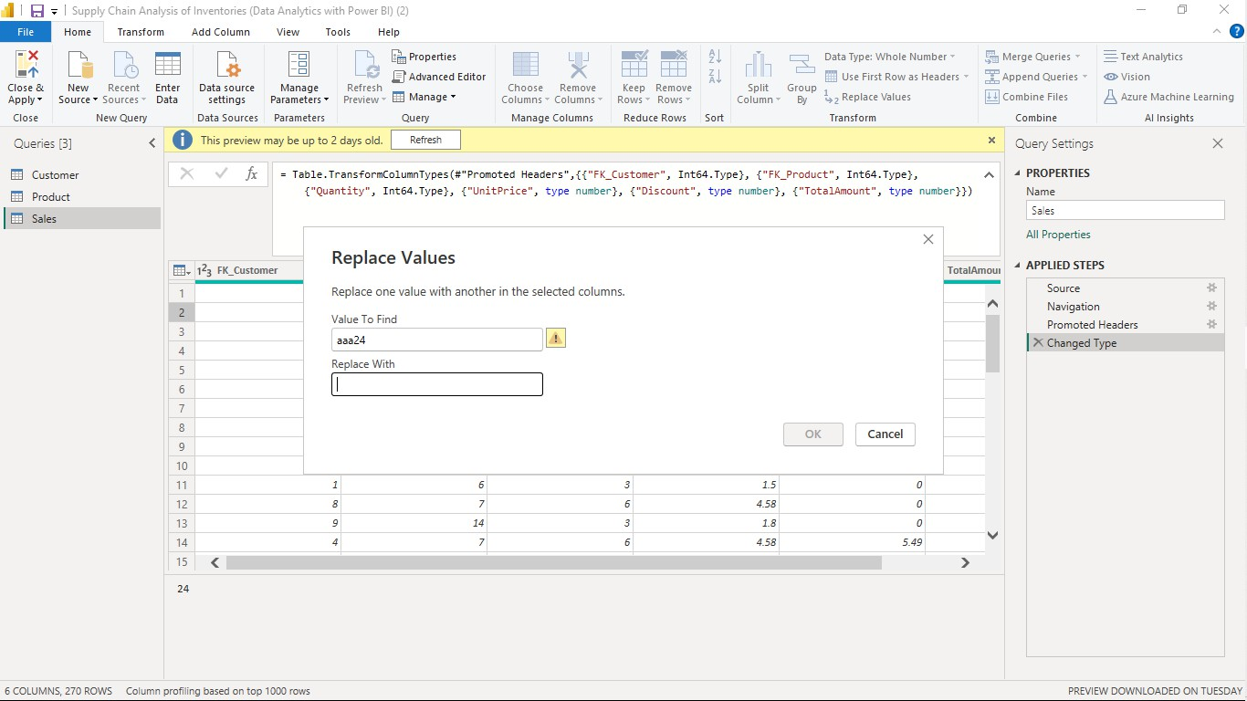

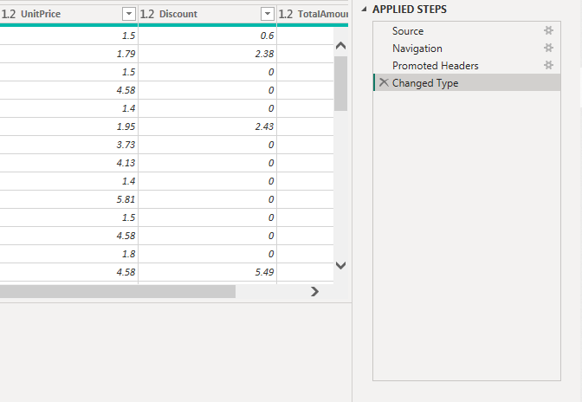

# Dashboard

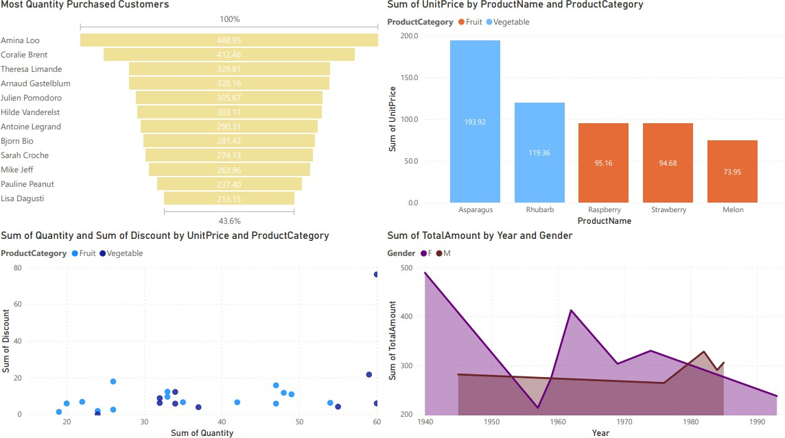

## CONCLUSION

In conclusion, the analysis of inventories within the supply chain is paramount for businesses aiming to achieve operational excellence and competitive advantage. Through meticulous examination of inventory data, trends, and performance metrics, organizations can make informed decisions that optimize inventory levels, enhance forecasting accuracy, and improve supply chain efficiency. By leveraging advanced analytics and modeling techniques, businesses can minimize carrying costs while ensuring the availability of goods to meet customer demand. Moreover, this analysis enables organizations to identify inefficiencies, mitigate risks, and drive continuous improvement throughout the supply chain. Ultimately, by prioritizing strategic inventory management and embracing data- driven insights, businesses can foster resilience, reduce costs, and maximize profitability in today's dynamic business landscape.

## FUTURE SCOPE

#### The future scope of supply chain analysis of inventories is poised for significant advancements driven by emerging technologies, evolving industry trends, and shifting consumer demands. As businesses increasingly recognize the critical role of inventory management in achieving operational excellence and competitive advantage, there is a growing focus on harnessing cutting-edge tools and methodologies to optimize inventory practices. One key aspect of the future landscape is the integration of advanced analytics and predictive modeling techniques, including machine learning and artificial intelligence, to enhance demand forecasting accuracy and optimize inventory levels dynamically. Real-time visibility and transparency across the supply chain will also become paramount, facilitated by technologies such as Internet of Things (IoT) sensors and blockchain, enabling organizations to monitor inventory movements, track performance metrics, and respond swiftly to disruptions. Furthermore, the concept of supply chain digital twins holds promise for simulating and optimizing inventory scenarios virtually, enabling organizations to test strategies and predict outcomes before implementation. Sustainability will emerge as a key focus area, with organizations prioritizing eco-friendly inventory practices and ethical sourcing to align with environmental and social responsibility goals. Collaborative supply chain ecosystems will continue to evolve, fostering greater cooperation and innovation among stakeholders to drive supply chain resilience and value creation. Personalized inventory solutions tailored to specific industry sectors and business needs will also gain traction, leveraging customizable software platforms and modular analytics tools. Finally, ethical and responsible supply chain practices will take center stage, with

organizations leveraging data analytics to monitor and ensure compliance with ethical standards throughout the supply chain. In summary, the future of supply chain analysis of inventories promises to be characterized by technological innovation, sustainability initiatives, collaboration, and a commitment to ethical practices, driving continued improvements in efficiency, resilience, and value creation.